GITHUB TASK
1. Install git.
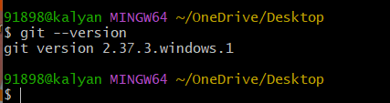
Description: to know the git version
Command: git –version

2. Create a repo in github with README.md and .ignore file.
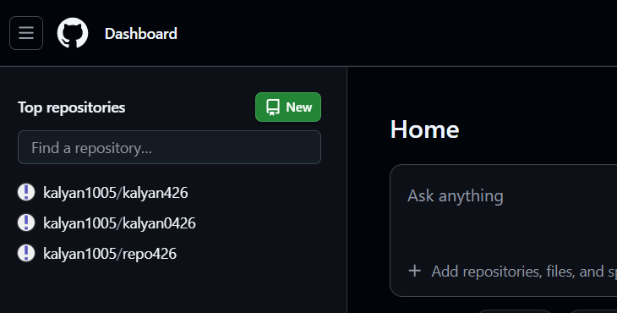
Click on new for creating a new repository.
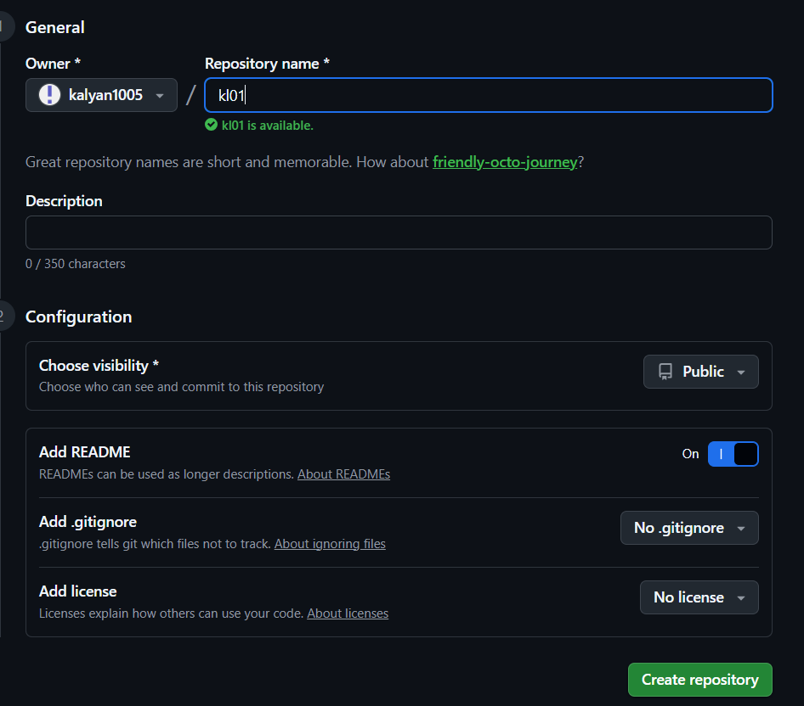
Description: Create a new repository.
Add repository name.
Add readme on, click on create repository.
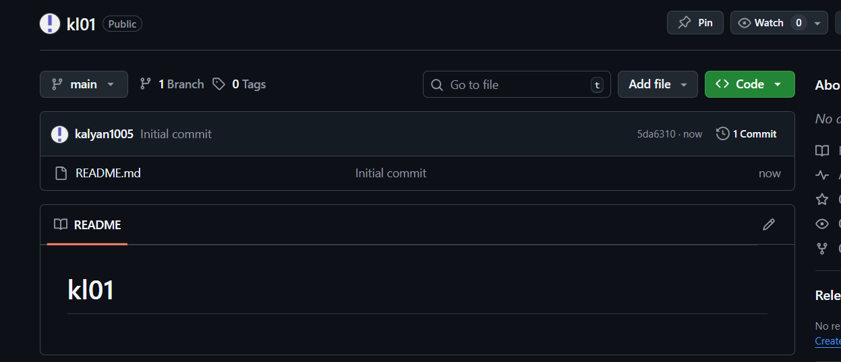
* New repository created with README.md
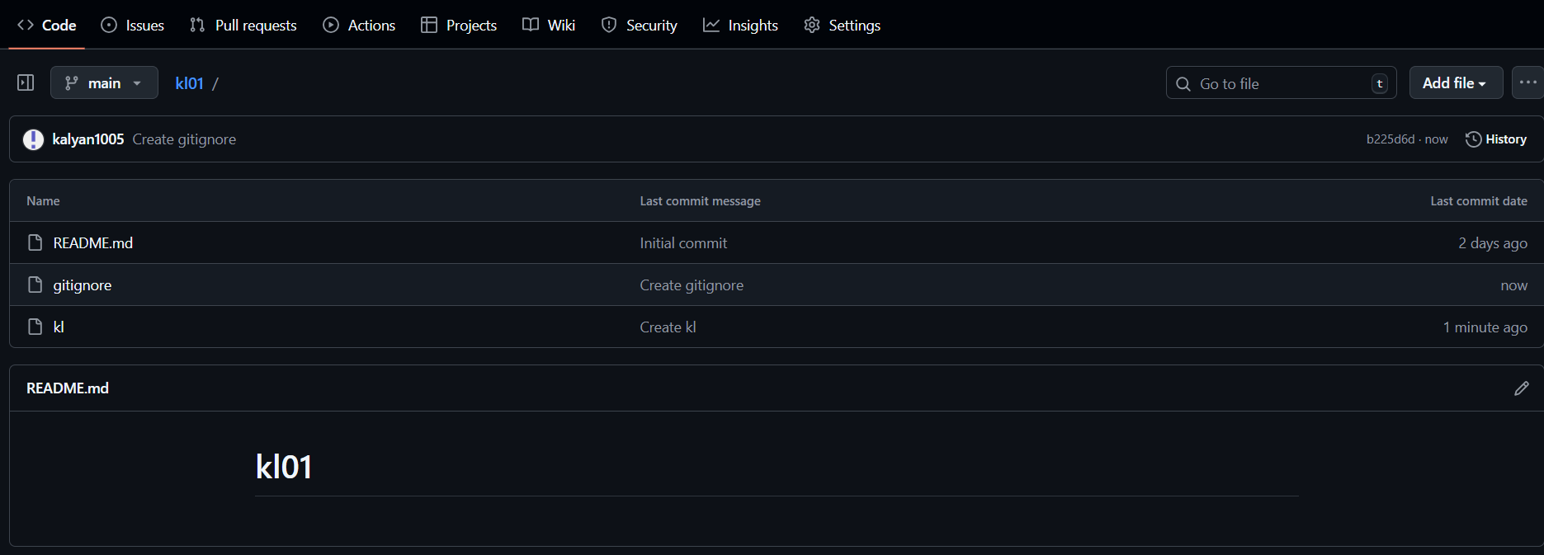
* Now create a .gitignore file in github so Now we have 3 files as shown.
3. Clone the created repo to local.
* Go to the repository and click on the required repository.
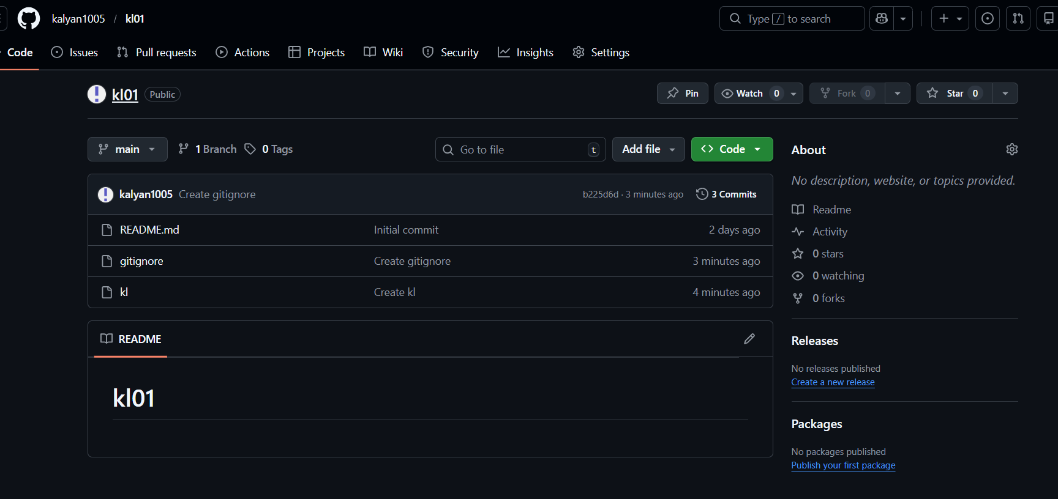
* Click on code copy SSH link.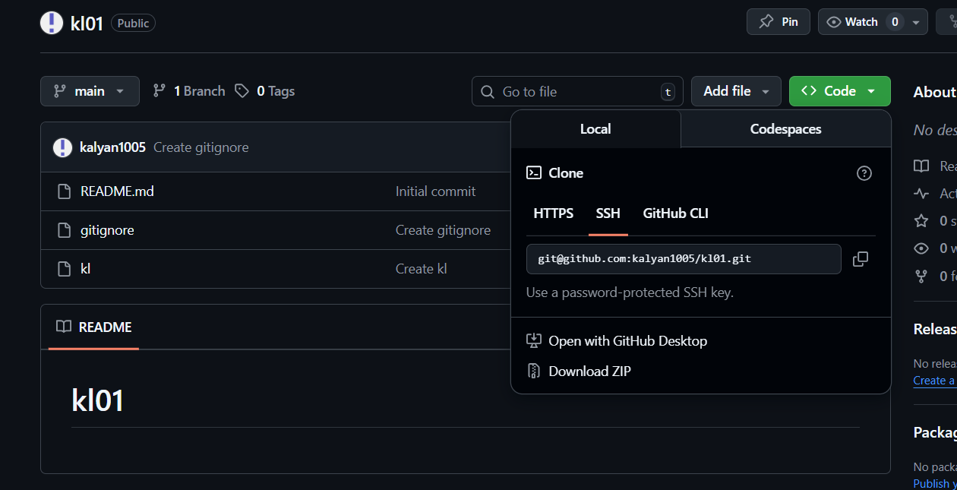
* To Clone the created repo to local command
$ git clone <URL>
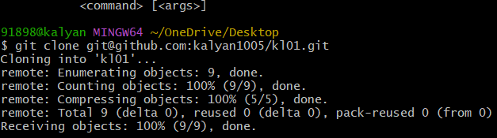
* ls repository name and check files present in it.
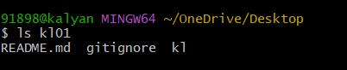

4. Create two files in local repo.
* First we should start git by git init command.
* Create files by using touch command.
* ls to check files present.
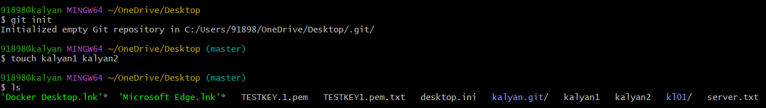

check git status whether the files are tracked or untracked
* By using git add . we can add files to tracked area
* Commit the changes by command
$git commit -m “Message”.
* Again we can check git status.
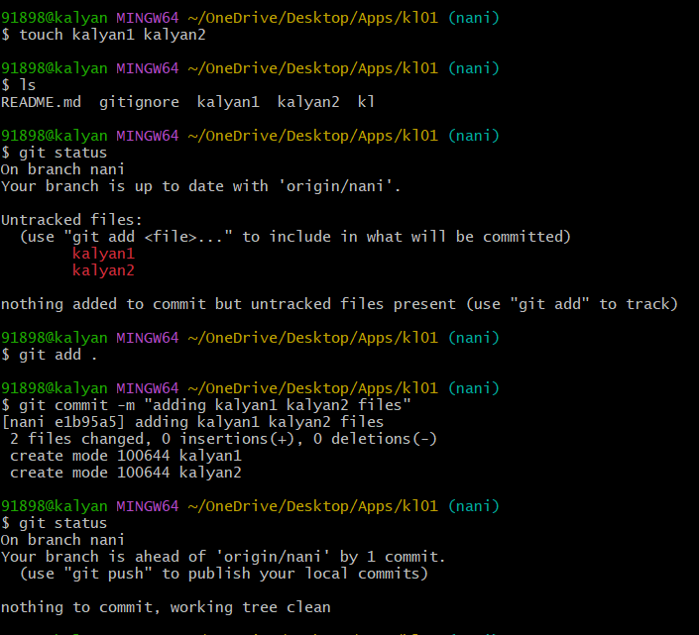

5. Commit two files and push to central Repository.
* check git status whether the files are tracked or untracked
* By using git add . we can add files to tracked area
* Commit the changes by command
$git commit -m “Message”.
* Again we can check git status.
* By using git remote -v we can check remote connections added or not.
* git push -u origin branch name.
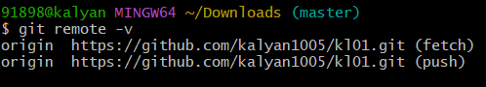

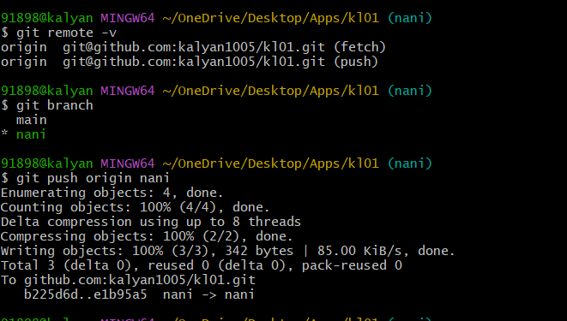

* To check files added or not click on correct repository and branch and verify files are added or not.

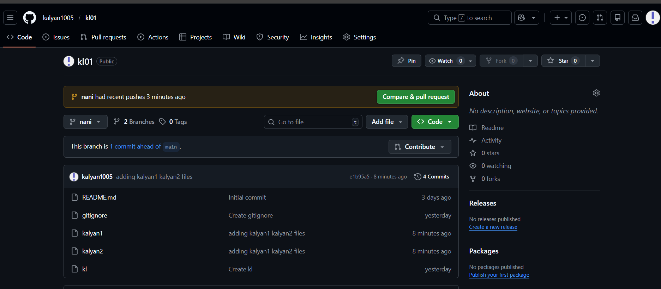

6. Create a branch in local and create a sample file and push to central.
• To create branch in local command
$git branch name
$git branch feature-branch
• To check branch command
$git checkout branch name
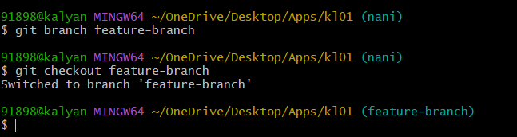

• Create sample file
• check git status whether the files are tracked or untracked
• By using git add. we can add files to tracked area
• Commit the changes by command
$git commit -m “Message”.
• Again we can check git status.
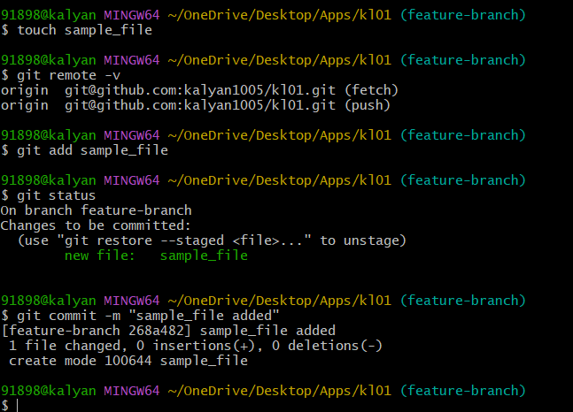

• Commit files and push to central Repository.
• $git push – u origin branch name.
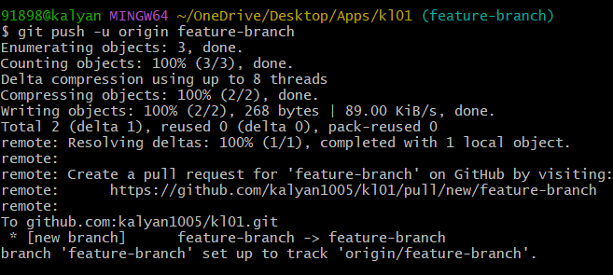

• Check in github whether files are moved to github.
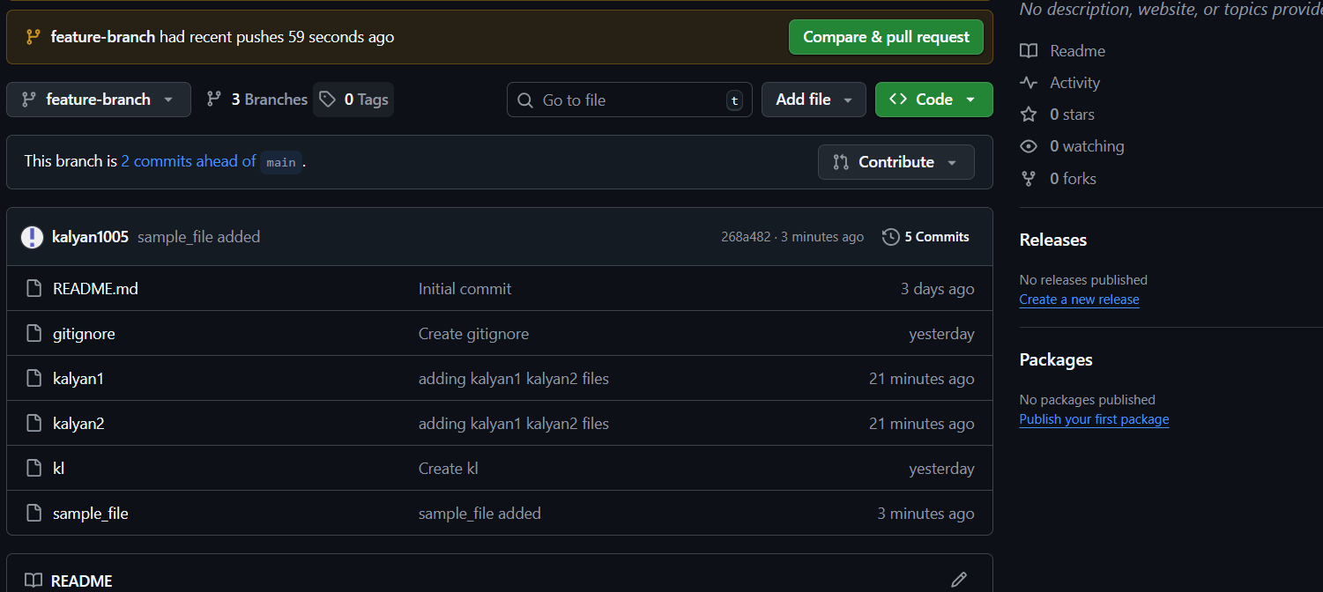

7. Create a branch in git hub and clone that to local.
branch is created in github.
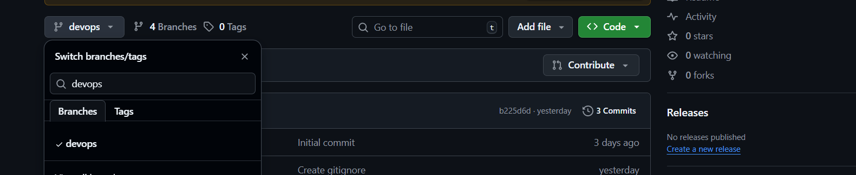
git clone url.
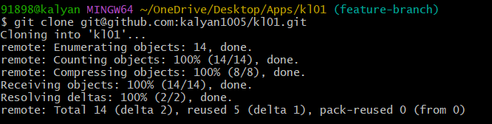
• By using ls check files are presented
• $ git fetch origin is used to check branches present and git branch
• * indicates present working branch
• To switch branch command
$ git switch branch name.
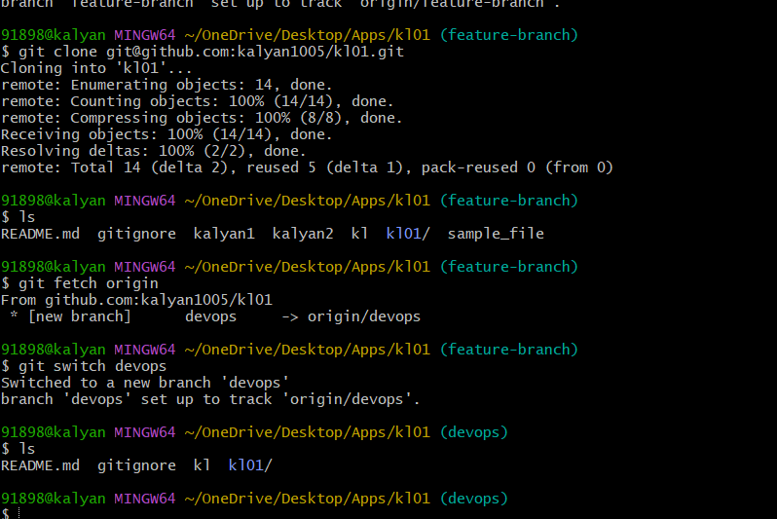

8. Merge the created branch with master in git local.
$git branch to check branches.
• $git check-out branch name to switch branch
• $git pull origin branch name used to cental to local transfer files.
• $git merge branch name
• $git log –oneline –graph --all
• $git push origin branchname
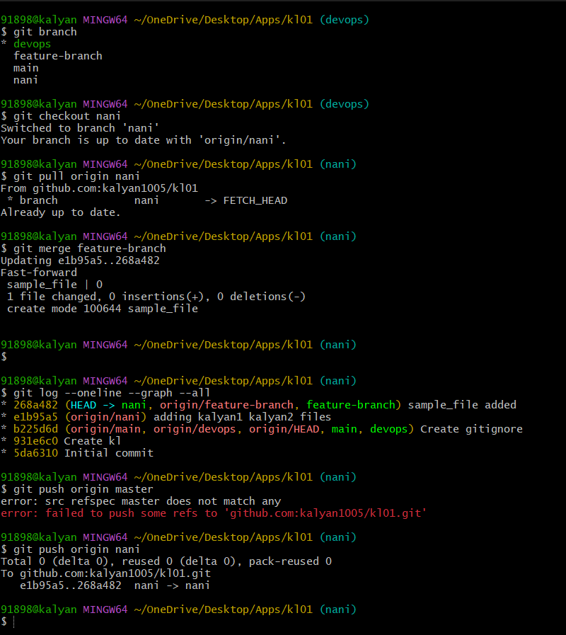

9. Merge the created branch with master in git hub by sending a pull request.
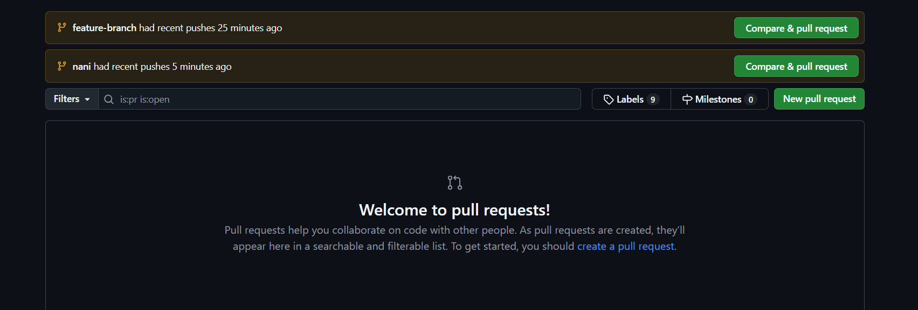
• Click on New pull request for creating pull requesting.
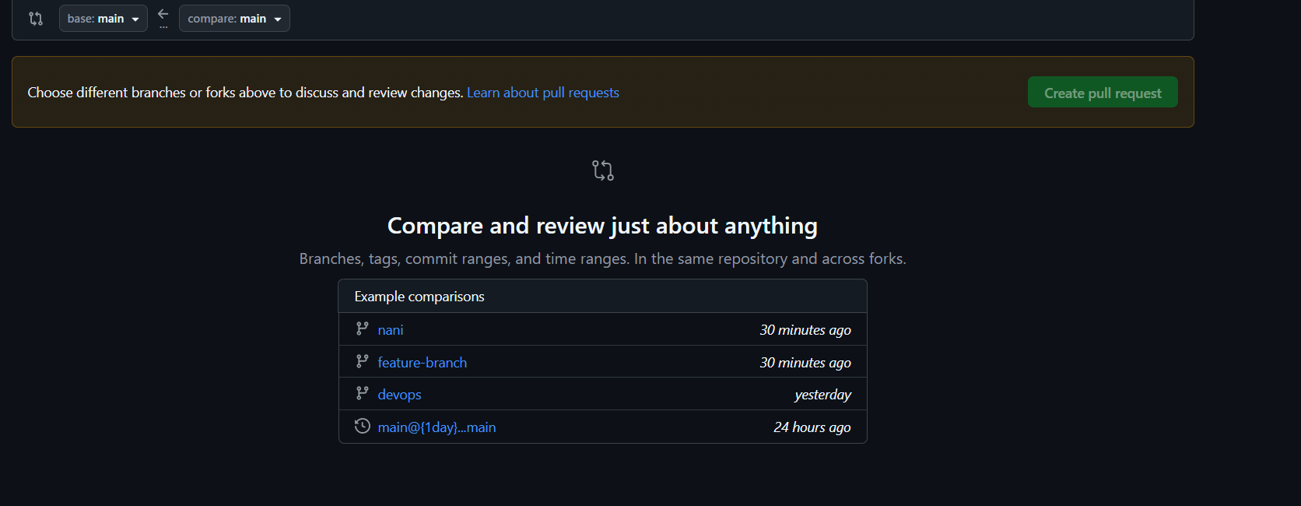
• Compare changes among two different branches.
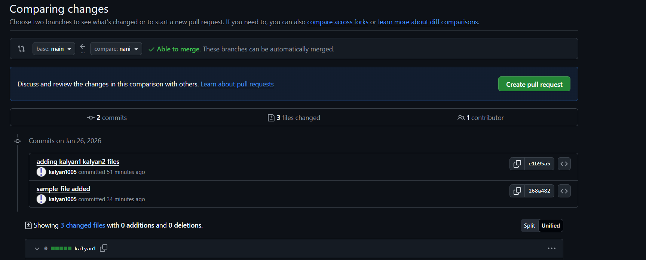

10.Create a file in local and send that to branch in github.
• Create a file in local machine
• git add . used for tracking
• git commit -m “msg” is used to commit.
• Create branch in github by switching to repository
$git branch new branch name.
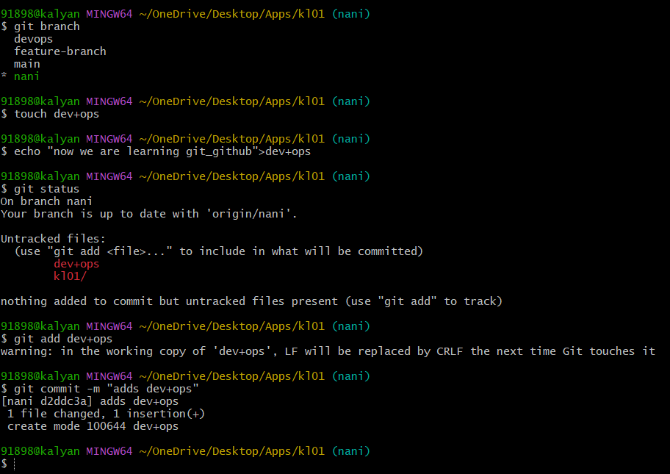
• $git push -u origin develop
• Files moved to local to github branch of repository.
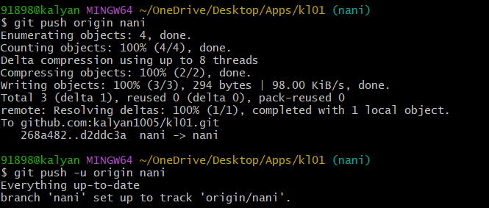

• The above image show files are transfer local to specific branch of repository
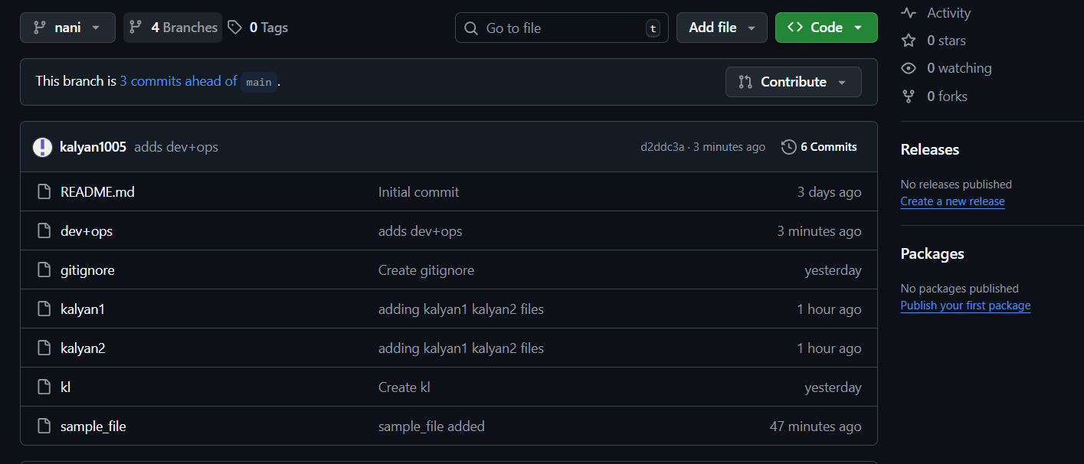

11.Clone only a branch from github to local.
• Clone by only branch command
• $git clone --branch branch name --single branch <URL>.
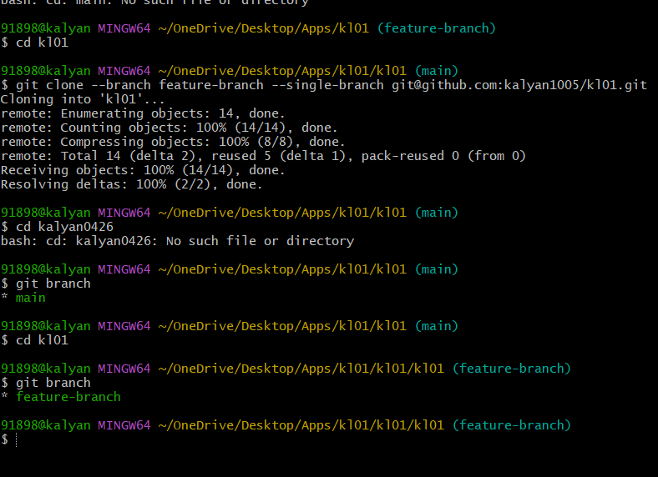

12.Create a file with all passwords and make that untrackable with git.
• Create file.txt
• Create other file name as .gitignore.txt.In that add file.txt
• git add .
• $git check-ignore -v file.txt
• $git push origin branch name
• $git status

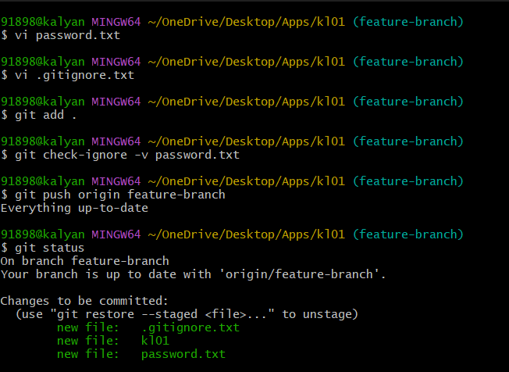

13.Make a commit and make that commit reset without savings change.
$git reset –hard is used for Make a commit and make that commit reset without savings change
• $git log –oneline.
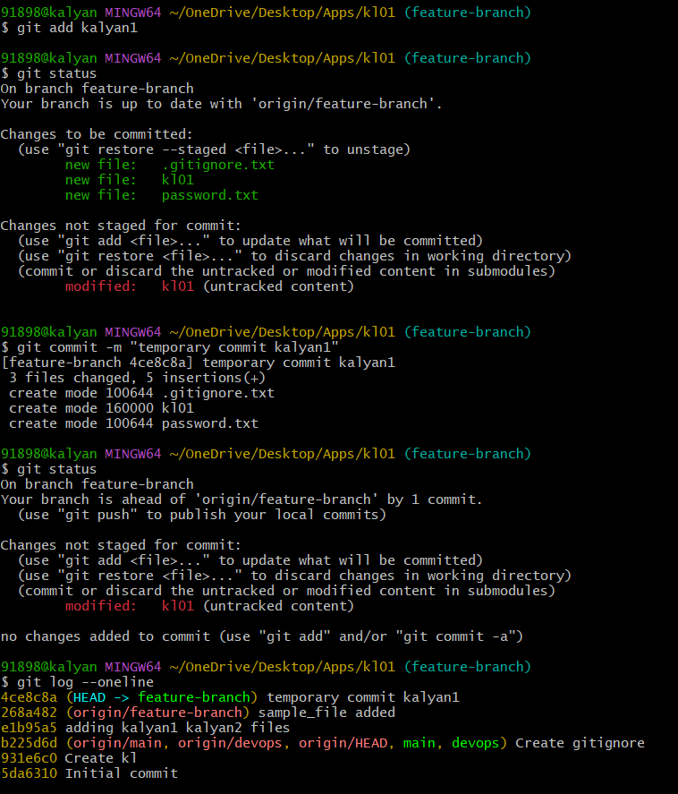
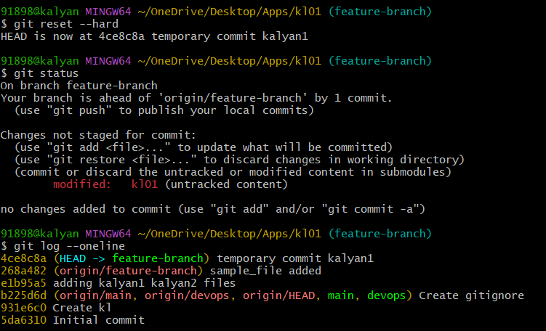

14.Revert a commited commit to the older version.
• $git revert head gives recent commits
• Vi will open and we can make changes and save it.
• Revert a commited commit to the older version
• Check through $git log –oneline.
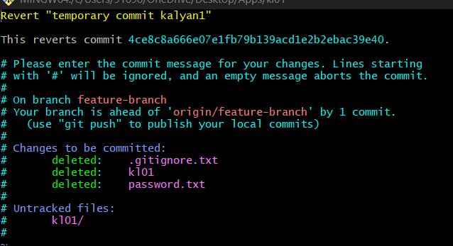

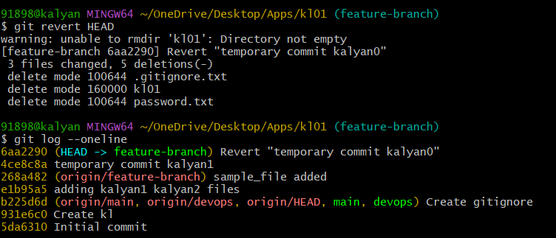

15.Push a file to stash without savings the changes and work on another file.
• Create file.txt
• git add .
• $git stash push -m “Message” filename.
• $git commit -m “message”
• $git stash list.

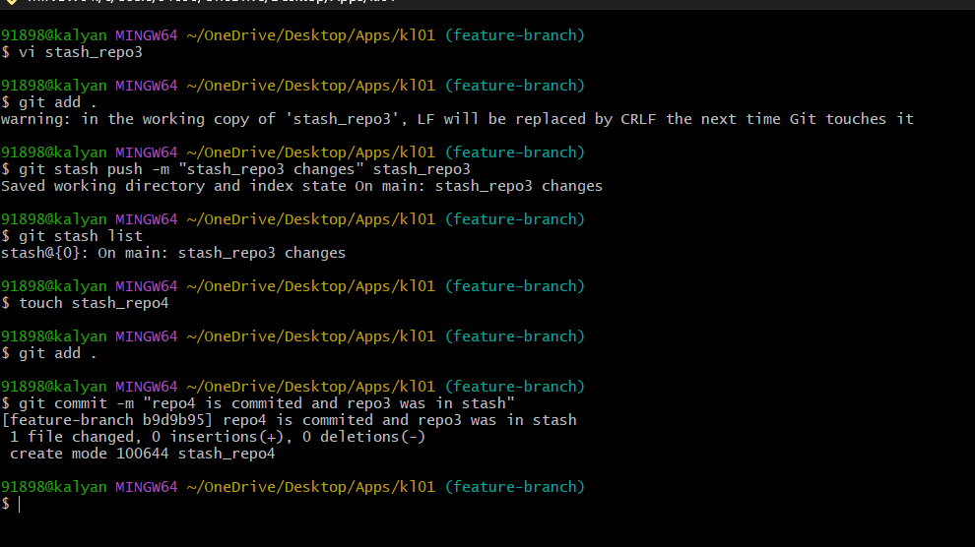

16.Undo the stash file and start working on that again.
• $git stash list
• $git stash apply stash@{0}
• $git stash pop stash@{0}
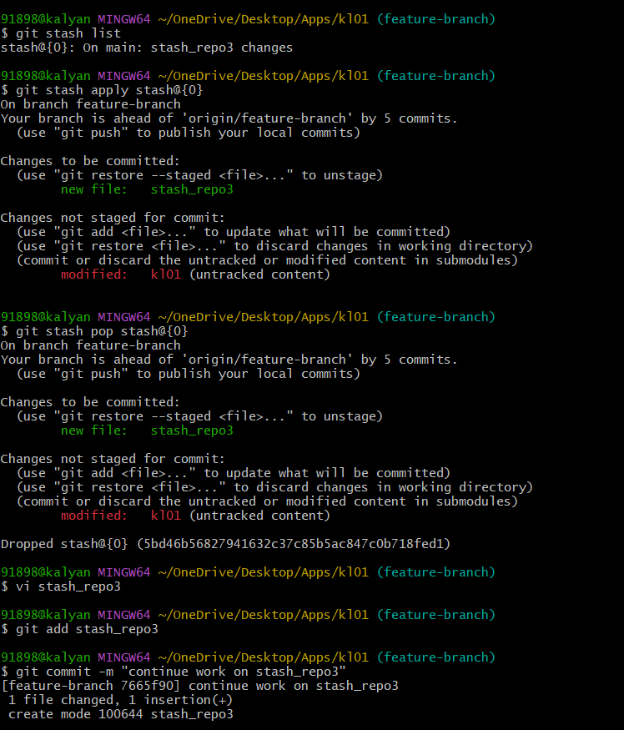

17.Generate a ssh-keygen and configure into github.
* for ssh connection
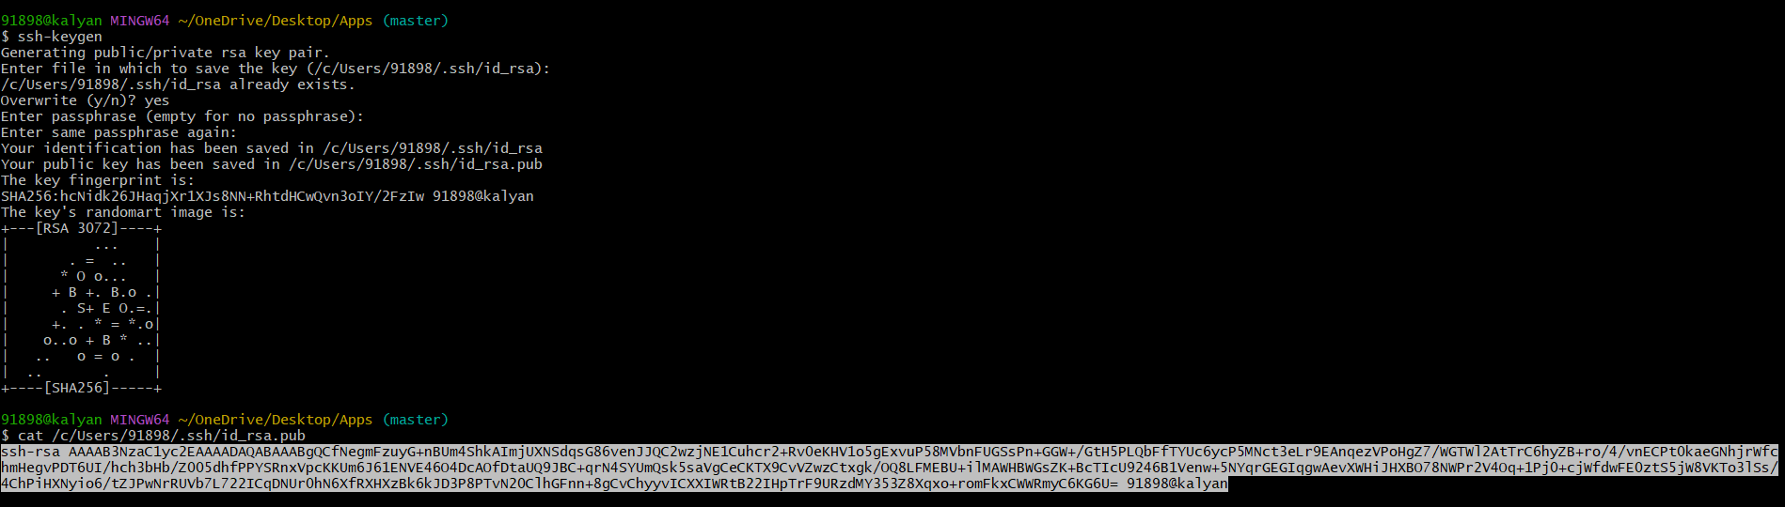
Go to setting and click on SSH and GPS keys and paste key and save changes.
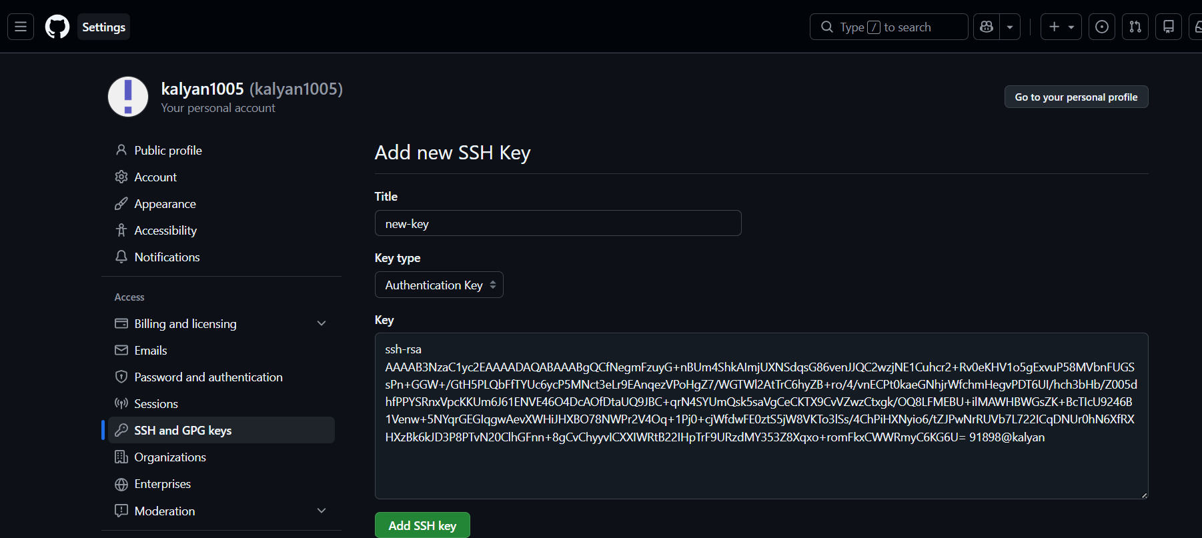
For MFA our respective email id and password enter and Verify it.
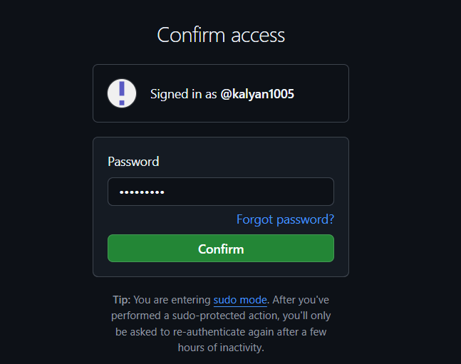
And you will get prompt as successfully added the key .
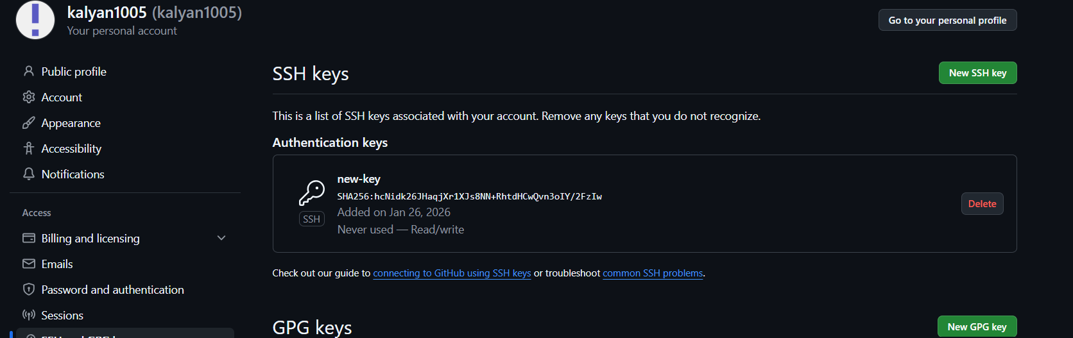

• To push files or data from git to github.
Command: git push -u origin feature-branch.
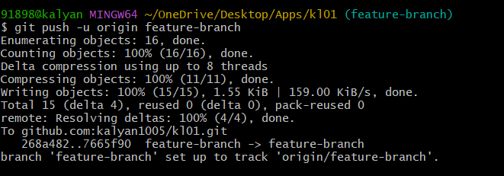

18.Configure webhooks to github.
• A webhook is a way for GitHub to notify another service when certain events happen in your repository (like push, pull request, or release).
• Example: Trigger a CI/CD pipeline, deployment script, or notification.
Step 1: Go to your repository
1. Open GitHub in your browser
2. Navigate to your repository
3. Click on Settings (top-right corner)
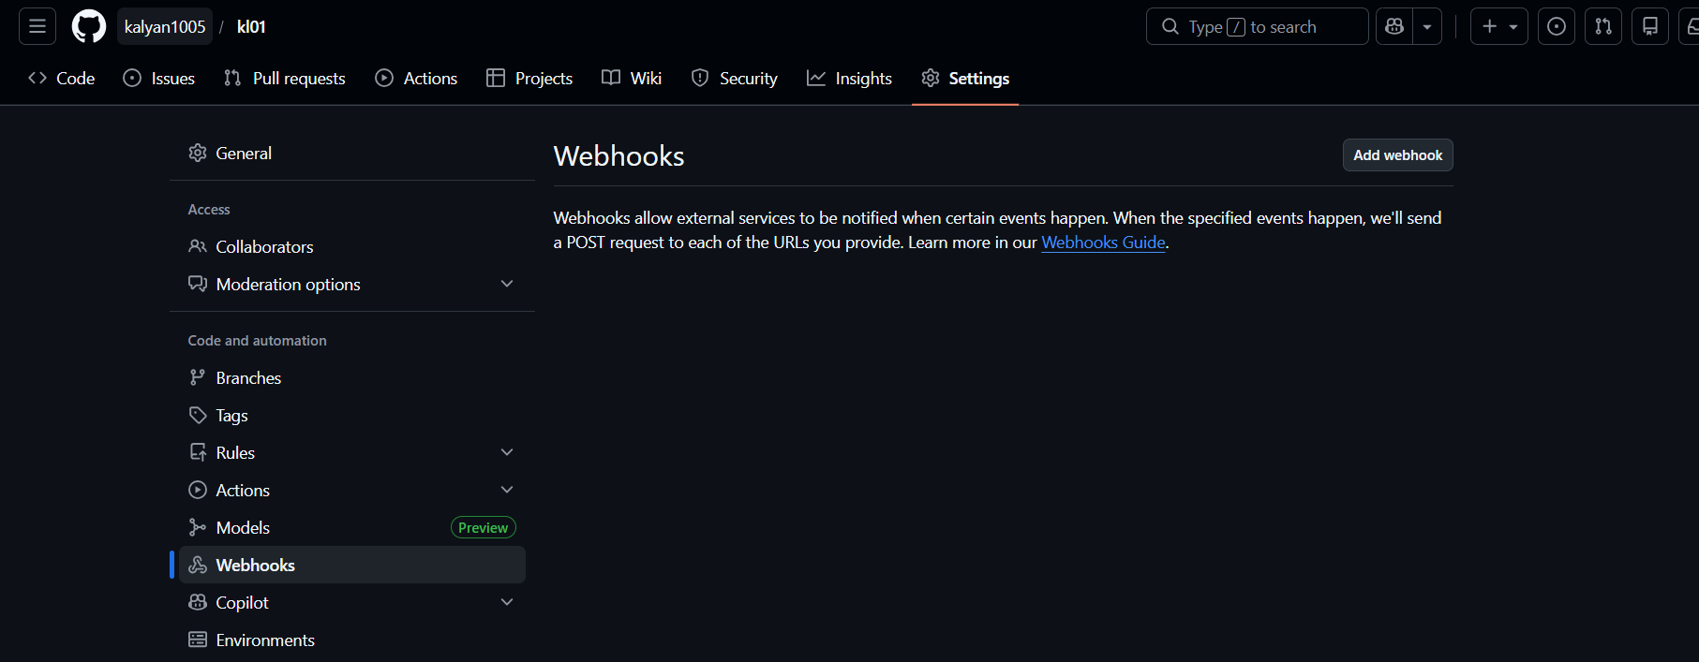

• Webhooks and create webhook and keep on active and click on add webhook.
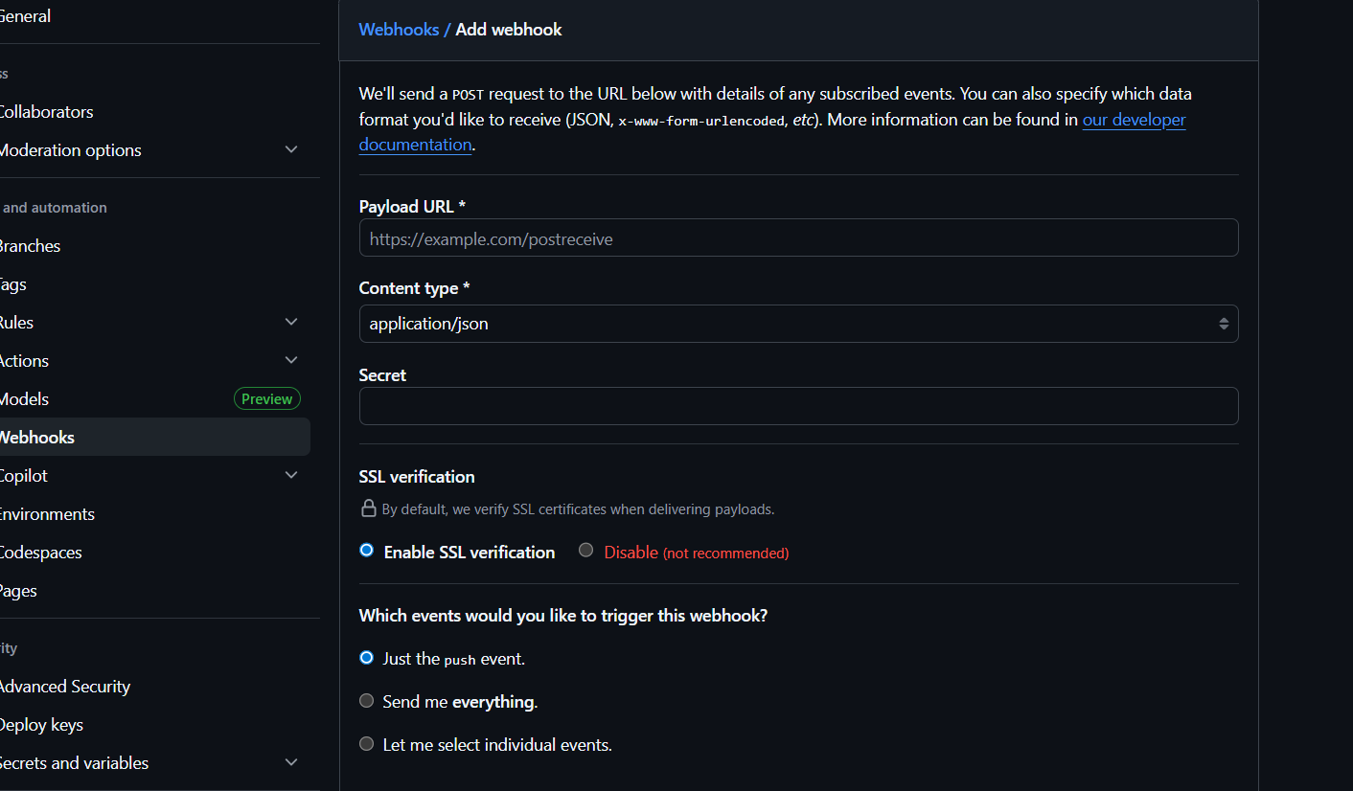

• After add webhook we can see this type successful creation of webhook.
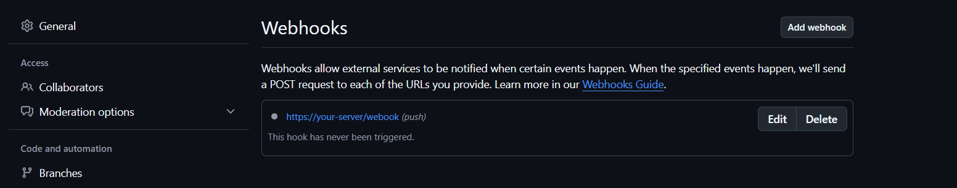

19.Basic understanding of .git file.
The .git directory stores everything necessary for version control. If you delete this folder, you lose your project’s entire history and git tracking.
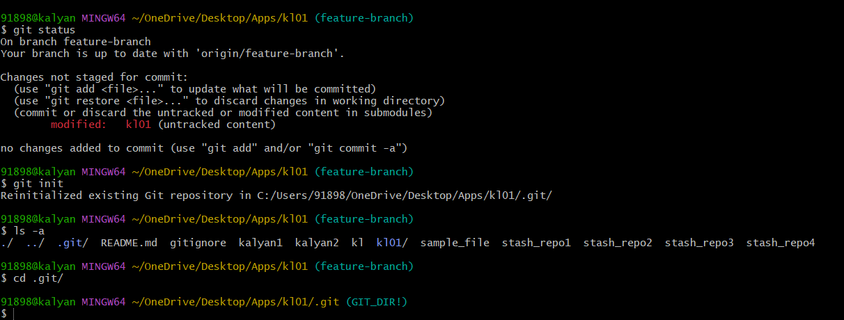

20.Check all the logs of git.
Check all commits : git log
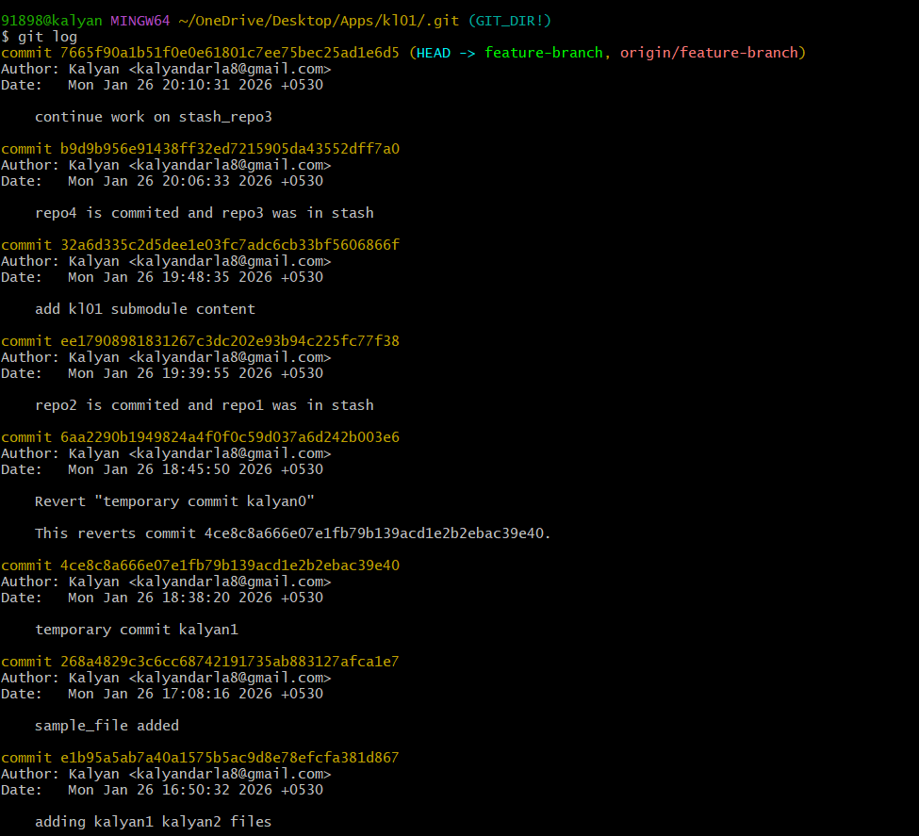
Compact commit log : git log –oneline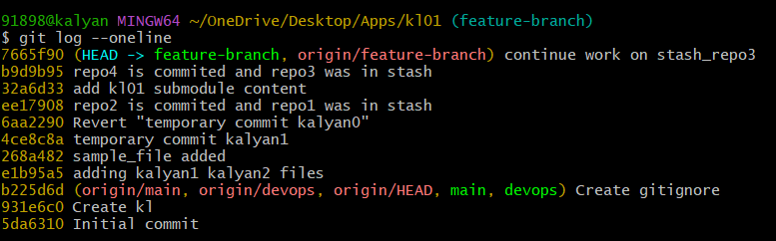

Git log -p : line by line changes (patch)
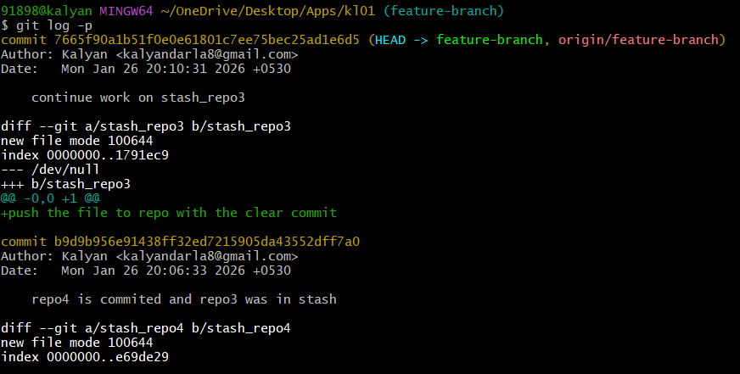
Git log –graph : visual brach graph
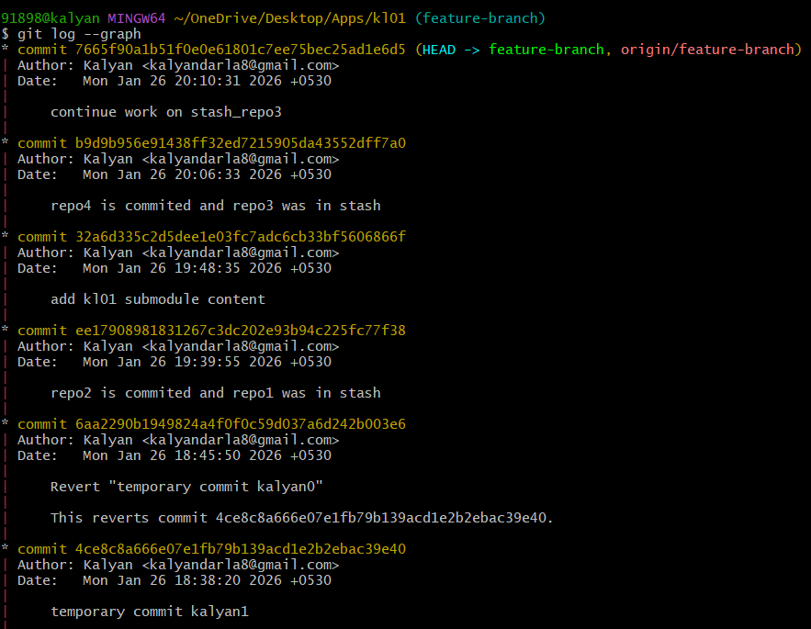

Log all branches : git log –all
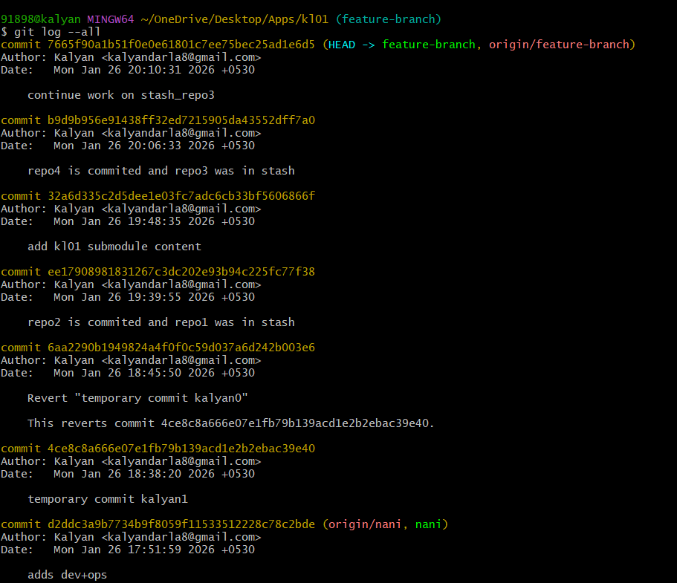
git shortlog : authors listed alphabetically
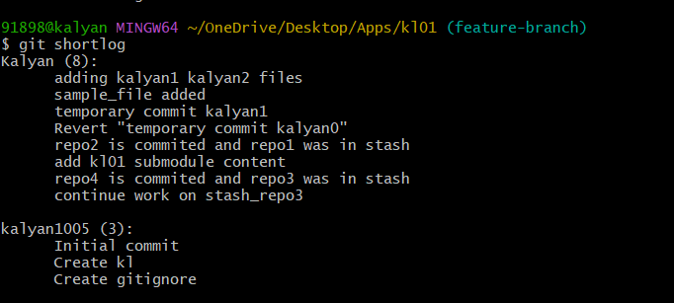

21.Rename the commit message.
• Rename commit message by 2 ways.
• git commit --amend -m “Message”
• git log --oneline
• git revert commit id
• In vi file change commit message and save file.
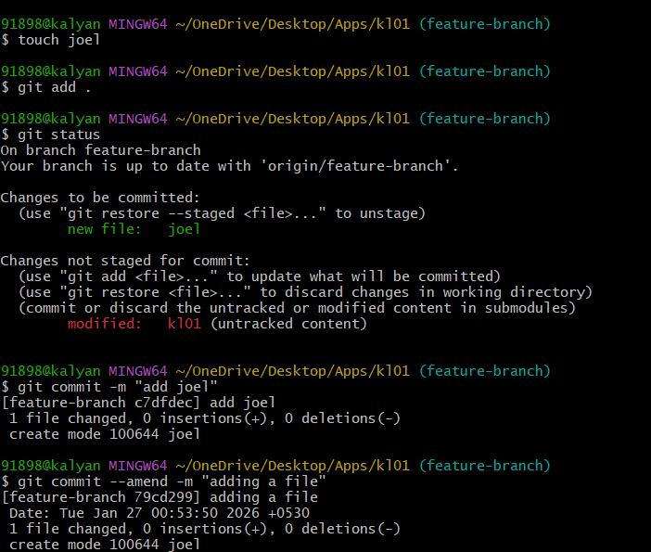

• git log --oneline
• git revert commit id
• In vi file change commit message and save file.
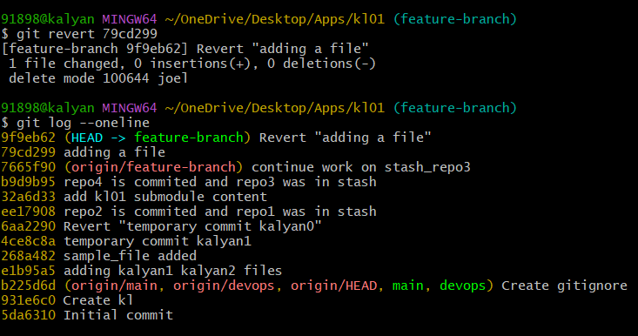

22.Merge multiple commits into single commit.
• In Git, merging multiple commits into one is called squashing commits. This is commonly done before merging a feature branch to keep history clean.
• Check commit history: git log –oneline.
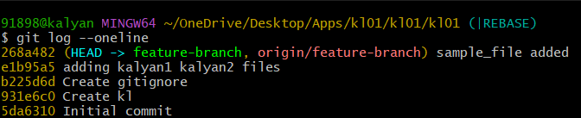

Start interactive rebase: git rebase -i HEAD~3
